**Automated Car Overspeeding Detection**

**FYP– I REPORT**

**BS(CS) Fall 2024**

Name: Usman Rasheed

21k-3225

Name: Talha Minhaj

21k-3347

Name: Muneeb Ali

21k-4924



**Supervisor: Sir Kashan Hussain**

**Department of Computer Science**

**FAST-National University of Computer & Emerging Sciences, Karachi**

Contents

1. Introduction 2

1.1. Overview 2

1.2. Functionalities 2

2. Related Work / (SRS/SDS) 3

3. Methodology 3

3.1. Initial Setup 3

3.2. The Workflow 3

4. Testing and Results 4

5. System Diagram 6

6. Goals For FYP-II 6

7. Conclusion 7

References 7

# Introduction

## Overview

In high-traffic areas with frequent, repeat vehicle visits such as universities, offices, and gated communities, overspeeding poses a significant safety risk. Existing systems either lack automation or rely on manual intervention, leading to inefficiencies in detecting, recording, and penalizing overspeeding drivers. Our Project aims to automate speed monitoring, license plate recognition, and fine management processes by combining technologies such as IR sensors, computer vision, OCR, and a MERN stack for data management and visualization to address those gaps.

## Functionalities

**Admin Functions:**

* Add, update, and delete user data, including vehicle number plates, owner names, and emails, through the admin interface.
* View detailed overspeeding records, including speed values, timestamps, and license plate images, for all vehicles.
* Update fine payments manually for individuals paying in cash.
* Maintain system functionality and ensure compliance with data privacy and traffic regulations.

**Vehicle Monitoring Functions:**

* Detect vehicle speed in real-time using IR sensors.
* Identify vehicles exceeding the speed limit and log details (number plate, speed value, timestamp, and license plate image) into the database.
* Classify users as "Registered" or "Unregistered" based on the database and update records accordingly.

**Notification and Fine Management Functions:**

* Send email notifications to registered vehicle owners with fine details, including payment options and deadlines.
* Record and manage the status of fine payments for each violation.

**Web Interface Functions:**

* Display a list of overspeeding records with associated details, such as timestamps and fines, on a user-friendly webpage.
* Provide insights on payment statuses, allowing the admin to track who has paid their fines.
* Offer an intuitive interface for managing registered and unregistered users' data.
* These objectives ensure the system automates over speed detection and fine management while providing admins with the tools to manage user data efficiently

# Related Work / (SRS/SDS)

Refer to SRS/SDS Document

# Methodology

## Initial Setup

Initially we must set up our hardware and our camera according to the street the device will be placed upon. In our code we set the speeding limit according to the location we are on.

## The Workflow

After the initial setup is complete we can elaborate on how the device works.

Firstly, a car will over speed through the street and be caught by the IR Sensors that connect to the Arduino, The Arduino will send the data to a python script that would then send a signal to a camera connected to the system, this camera will record the car driving and save the video upon the local device. Once the video is saved another python script will realize a video has been recorded and start processing the license plate, once it processes that a license plate does exist it will perform a character reading program through the use of the easyocr library. Once done it will check if the license plate belongs to someone through the users table in the database, in the case it doesn’t it will mark the user unregistered and upload the data to the database’s overspeeding table, if a user exist it will upload said user’s name and other details to the overspeeding database, and send an email to that user for performing over speeding. The database will also include an is fine paid column, a timestamp column and the fine price column. Once it is all done an admin can view all the details on the webpage and perform crud operations on the data, including updating the fine.

# Testing and Results

Currently we have trained our AI Model for license plate detection to 15 epochs with an accuracy of 97%.

Similar results were seen when testing out with real world number plates.

Initially we were using a live camera using computer vision, but this variation of the camera would get heavily bottlenecked by the cpu constantly performing checks for the license plate, slowing down the camera’s frames to be at approximately 2 fps, regardless of the camera. We have instead opted for a recording variation where the camera instantly opens up at the response of the IR sensors and records a clip of the over speeding offense, this recording is then processed and does not get bottlenecked by the cpu, having the same framerate as the camera provided.

Currently the IR Sensors we used were of cheap quality and had short range that being said they performed well when it came to their delay of just 0.5 ms, newer IR Sensors have been ordered that have improved range and the same delay as the cheap variant.

Images of the AI Models are provided below:

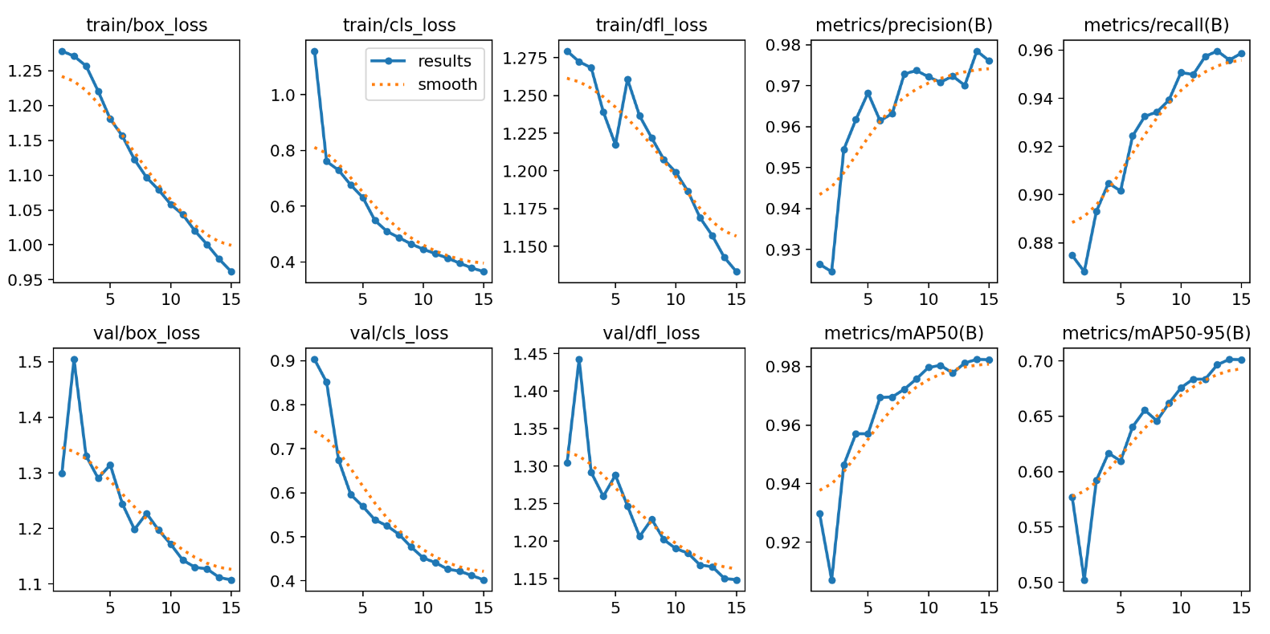

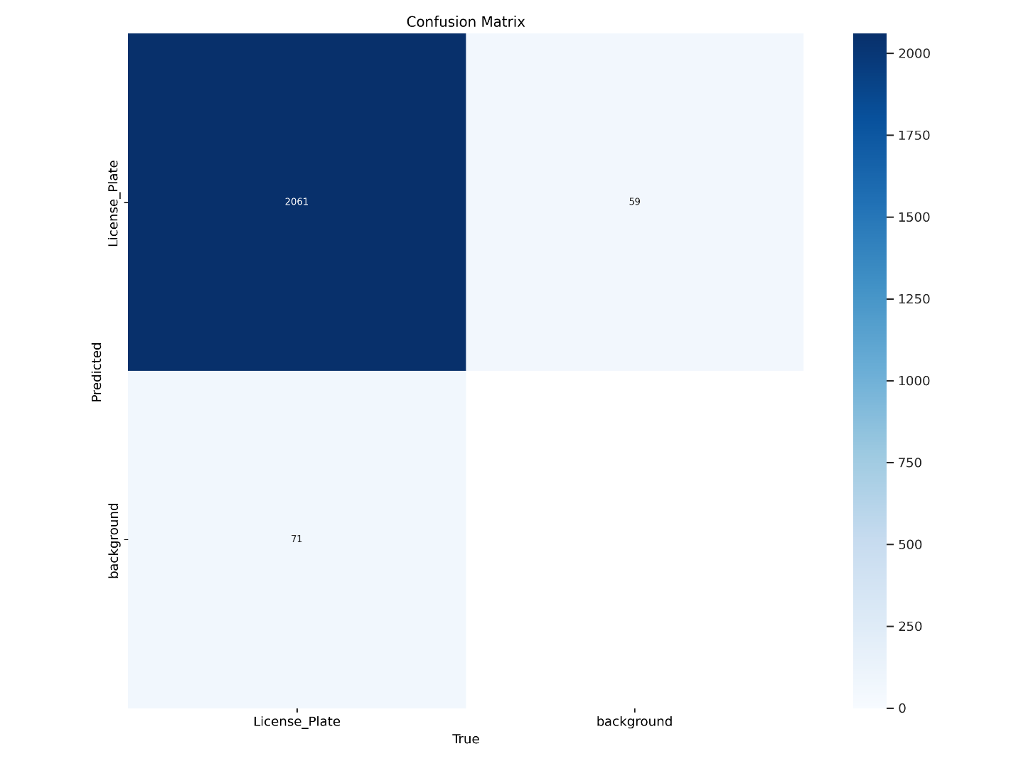

# System Diagram

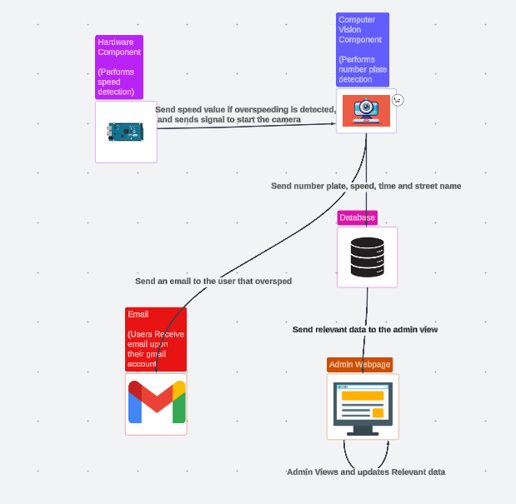

# Goals For FYP-II

Our Future goals include:

The completion of the Computer vision module

The Completion of the MERN Module

Performing integration upon all the modules and making sure everything runs smoothly

Finalization of the project, with everything updated accordingly

# Conclusion

Our project the automated car overspeeding detection is performing well according to our deadlines, a slight hiccup has been faced in the Computer vision module but that has been made up with the hardware module fully functioning.

Moving forward we hope to continue our project by finishing the CV Module and then starting promptly with the MERN module. We have high hopes for the project’s success and expect it to be a staple in many institutes due to its cheap quality and ease of setup, especially since it is extremely hard or impossible to find anything to compete with it at its current scale.

# References

1. Ali, S., & Singh, R. (2021). **AI-Powered Traffic Monitoring and Law Enforcement Systems**. *Journal of Intelligent Transportation Systems*, 13(2), 89-104.
2. Jain, R., & Srivastava, D. (2021). **Challenges in Automated Number Plate Recognition for Traffic Systems**. *International Journal of Smart Transportation*, 11(3), 67-82.
3. Khan, M., & Ahmed, S. (2022). **The Role of Smart Traffic Systems in Urban Management**. *International Journal of Urban Planning*, 14(4), 134-149.
4. Kumar, P., & Verma, S. (2020). **Technological Advancements in Speed Detection Systems for Smart Cities**. *IEEE Transactions on Smart Systems*, 15(3), 76-89.
5. Nguyen, H., & Patel, R. (2019). **Real-time Traffic Monitoring Using Radar and ANPR**. *IEEE Journal of Transportation Technology*, 12(1), 98-112.
6. Sharma, K., Verma, R., & Gupta, A. (2020). **Deep Learning Techniques in Automated Number Plate Recognition**. *International Journal of Computer Vision Applications*, 13(2), 45-58.
7. Zhao, Y., Liu, J., & Chen, H. (2021). **Advanced ANPR Systems Using Convolutional Neural Networks**. *Journal of Transportation Engineering*, 148(1), 345-359.

IEEE Reference and Citation guideline